Lab 11

Section A – Importing & Model Setup
Q1. Import CSVs into Power BI
Import all four CSVs:
● dim_date
● dim_customer
● dim_product
● fact_sales
Done

Q2. Build the Data Model
1. Create relationships:
○ fact_sales.date_key → dim_date.date_key
○ fact_sales.customer_key → dim_customer.customer_key
○ fact_sales.product_key → dim_product.product_key
2. Set Cardinality = Many-to-One
3. Set cross-filter direction = Single

Section B – Basic DAX Measures
Q3. Create the Following Basic Measures
Create 6 measures:
1. Total Revenue
2. Total Quantity
3. Average Revenue
4. Distinct Customers
5. Average Order Value
6. Max Revenue Day
Done

Q4. Visualize These Measures
Add them to:
● Card Visuals
● Table Visual
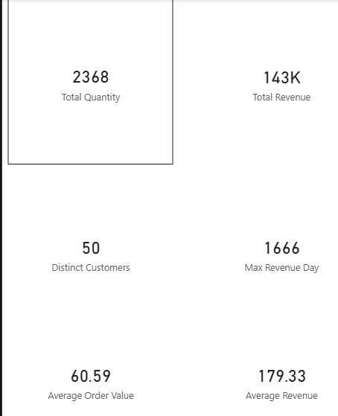

Section C – Intermediate DAX
Q5. Create 5 Intermediate DAX Measures
Create the following measures using DAX logic:
1. ARPU (Avg Revenue Per User)
ARPU = DIVIDE([Total Revenue], [Distinct Customers])

2. Revenue Contribution % per Category
Revenue Contribution % =
DIVIDE(
[Total Revenue],
CALCULATE([Total Revenue], ALL(dim_product[Category]))
)

3. Total Revenue (Online Only)
Total Revenue (Online Only) =
CALCULATE(
[Total Revenue],
fact_sales[Channel] = "Online"
)

4. Total Revenue (In-Store Only)
Total Revenue (In-Store Only) =
CALCULATE(
[Total Revenue],
fact_sales[Channel] = "In-Store"
)

5. Customer Revenue Rank (Ranking by revenue)
Customer Revenue Rank =
RANKX(
ALL(fact_sales[CustomerID]),
[Total Revenue],
,
DESC
)

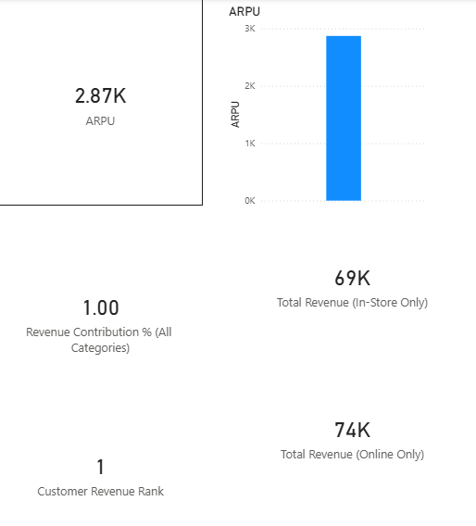

Q6. Donut Chart for Revenue Contribution
Create a Donut Chart showing Revenue % by:
● Category

● Region
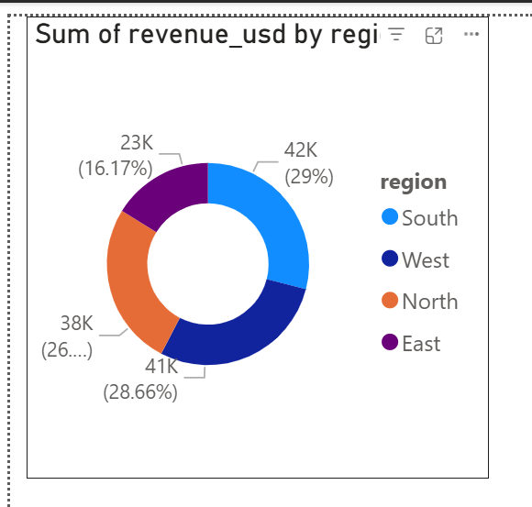

Section D – Time Intelligence
Q7. Create Time-Based DAX Measures

1. MTD Revenue
MTD Revenue =
TOTALMTD([Total Revenue], dim_date[Date])

2. QTD Revenue
QTD Revenue =
TOTALQTD([Total Revenue], dim_date[Date])

3. YTD Revenue
YTD Revenue =
TOTALYTD([Total Revenue], dim_date[Date])

4. YoY Revenue Difference
YoY Revenue Difference =
[Total Revenue] -
CALCULATE([Total Revenue], DATEADD(dim_date[Date], -1, YEAR))

5. YoY Revenue Growth %
YoY Revenue Growth % =
DIVIDE(
[YoY Revenue Difference],
CALCULATE([Total Revenue], DATEADD(dim_date[Date], -1, YEAR))
)

Section D – Q8 Visuals
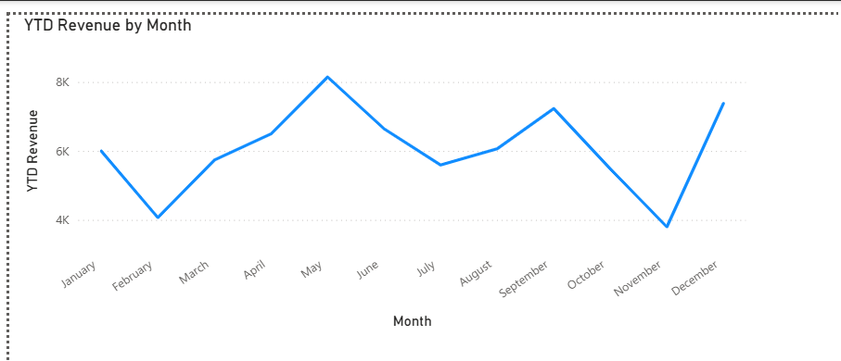

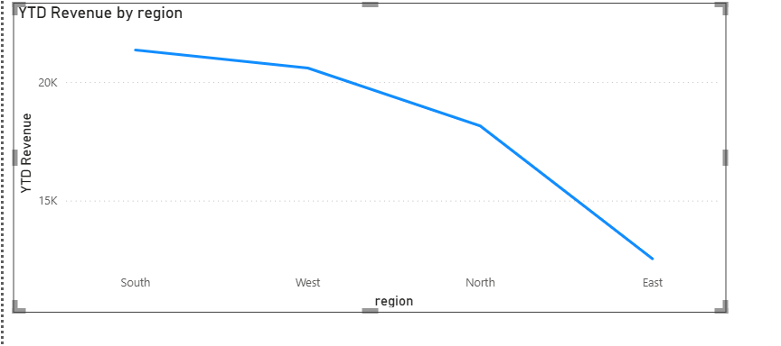

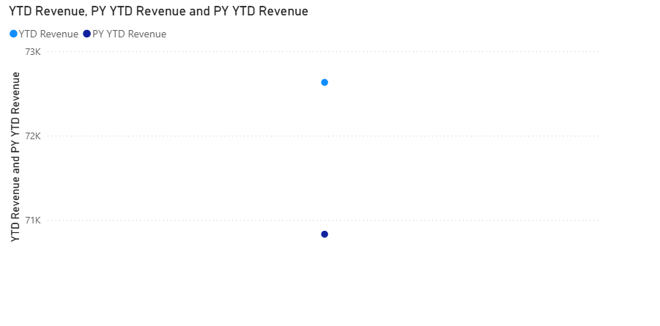
Section E – Dashboard Assembly
Q9. Build a Complete Dashboard
